הקף בעיגול את הצורה הנכונה של הפועל BE
Circle the correct form of the verb BE:

1. She am / is 12 years old.
2. Dan and Rina is not / are not students in high school.
3. You am / are very excited today.
4. My cat is / are black and white.
5. People am not / are not going to the mall today.
6. Gold am / is a very expensive metal.
7. Am / Are you celebrating your birthday today?
8. I am / is very happy that you are here with me.
9. Young children are / is sometimes afraid of the dark.
10. Is / Are David new in Maale Adummim?

השלם את המשפטים הבאים עם Have / has
Complete the following sentences with have or has:

1. David _______________ two brothers and one sister.
. I ________________ a lot of homework today.2
3. My aunt _____________ a big factory in Haifa.
4. Or and Tali_______________ a beautiful new baby.
5. Teachers ______________ a lot of work to do.
6. This machine ______________ a small computer in it.
7. We _____________ guests from Russia today.
8. Sharon ______________ lots of funny hats.
. They _______________ a great sense of humor.9
10. This table ____________ only three legs.

There is / There are
הביטי בתמונה:
Look at the picture:
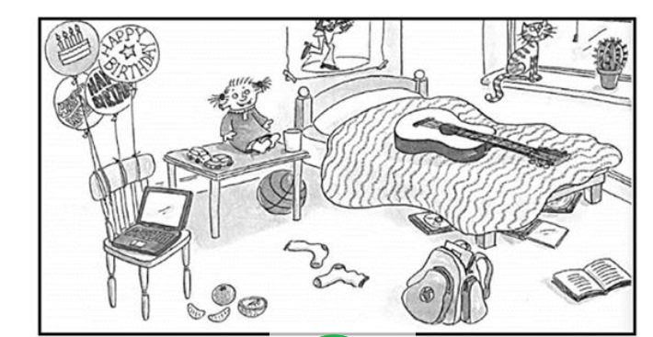

השלימי את המשפטים הבאים עם There is / There
Complete the following sentences using There is / There are:
- ______________ a computer on the chair.
- ______________ cars on the table.
- ______________ a guitar on the bed.
- ______________balloons in the room.
- ______________a ball under the bed.
- ______________toys in the room.
Reading Comprehension – תרגול הבנת הנקרא

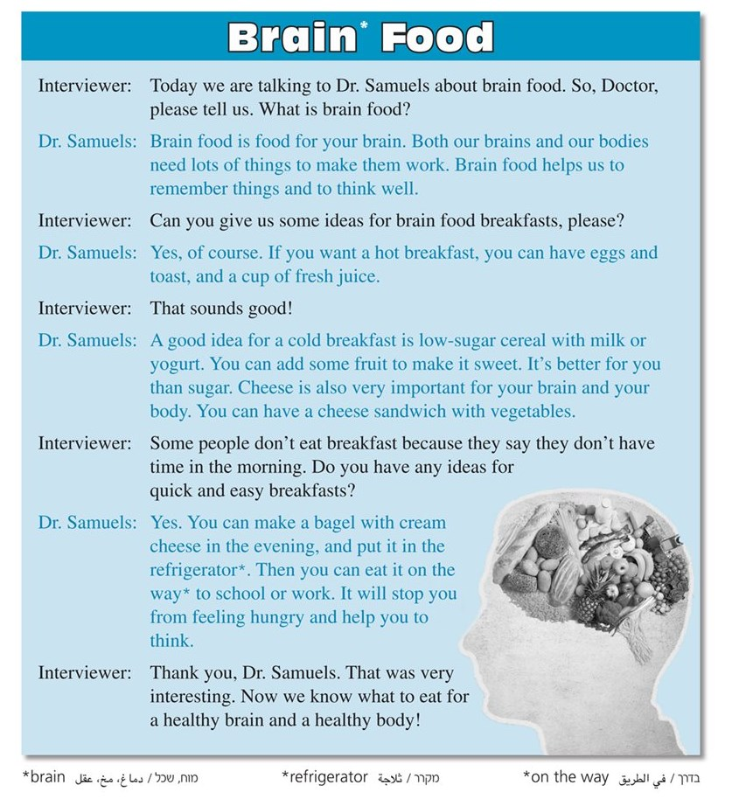

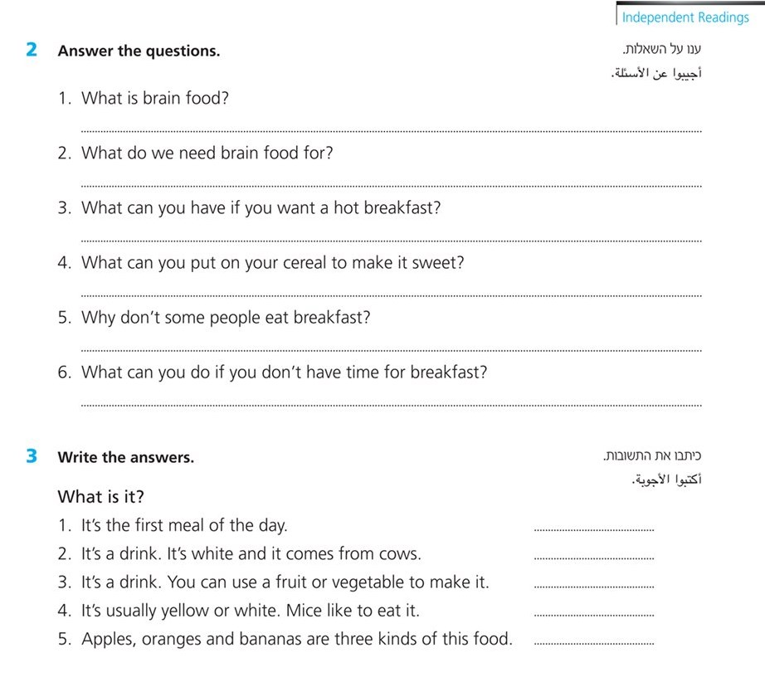

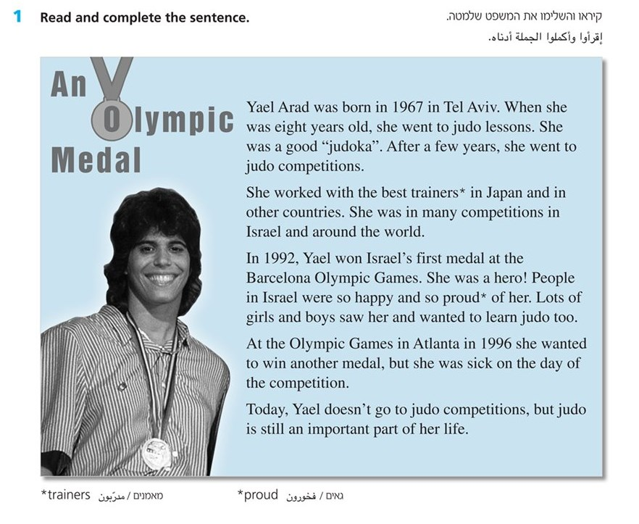
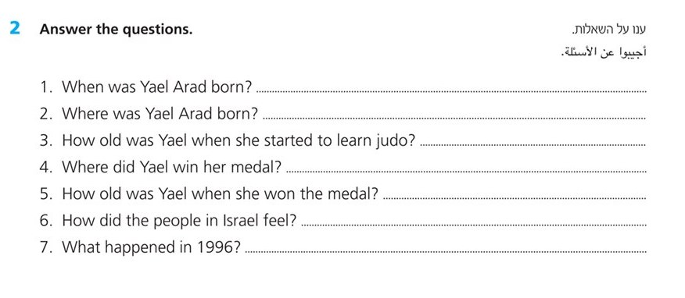
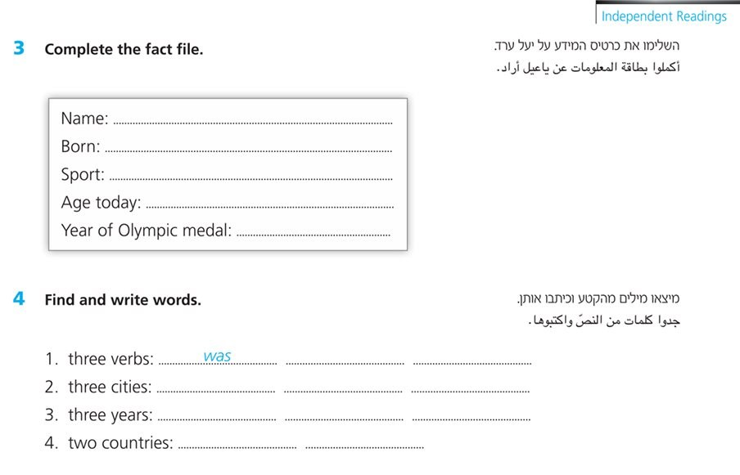

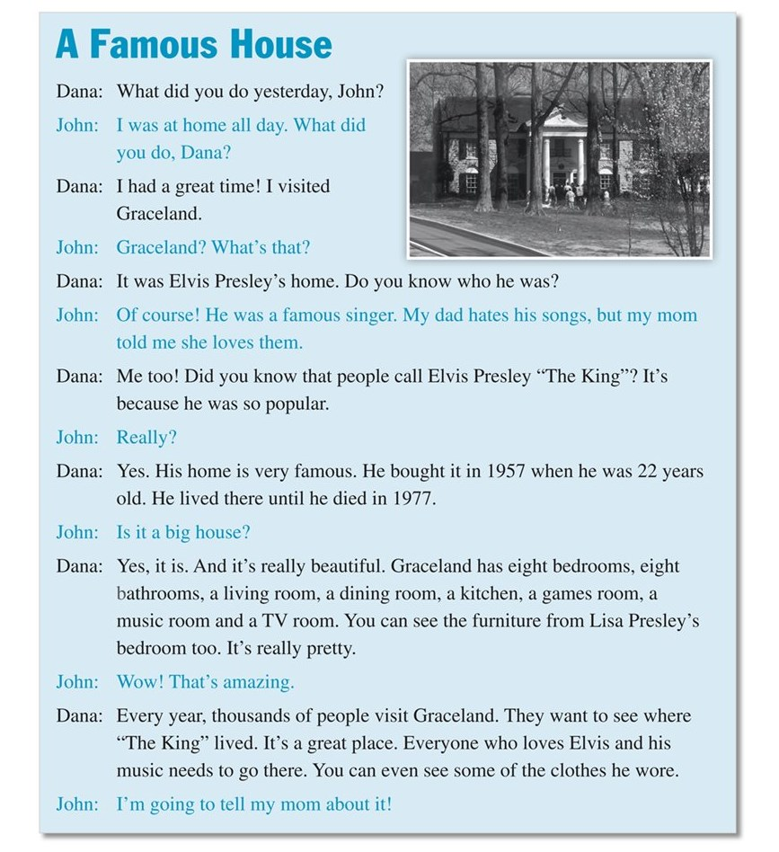

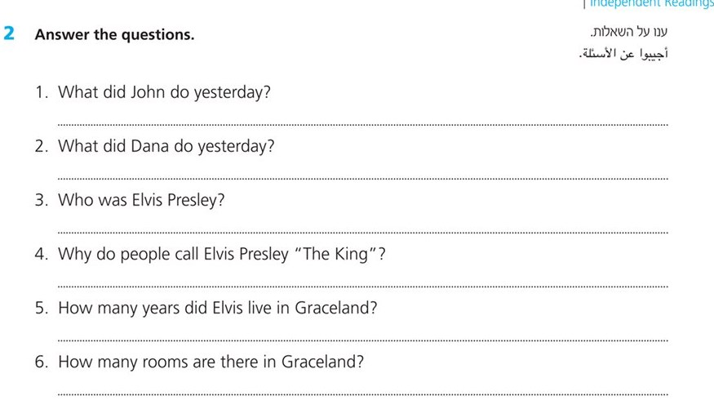

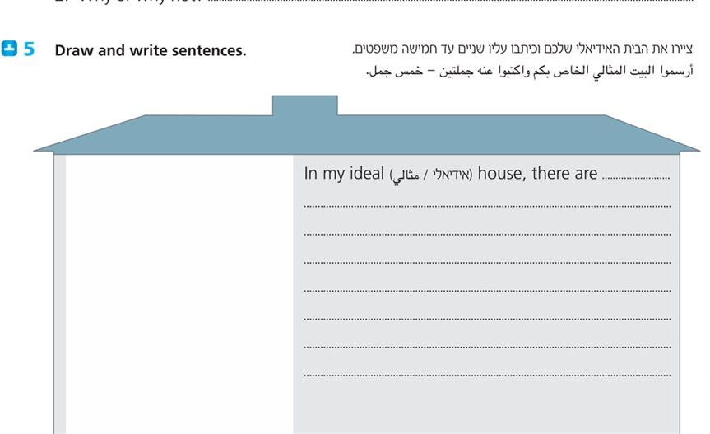

Now and Then Magazine May, 2019
BACK In Time - by Jack Smith
Do you want to go back in time? Buy a ticket and visit the Living
History Museum in Florida, USA. This special museum looks like a real
village, and all the people that work there are actors*. When you visit
the museum, you can see how people lived 400 years ago. You can
watch the actors build houses, grow fruit and vegetables and cook
their meals over the fire. They don't have televisions, computers or
phones. There are no cars; the actors ride horses to go from place to
place.
Many people from all over the world come to visit the Living History
Museum. The actors take the visitors around the village and teach
them about life a long time ago. Sometimes the visitors ask the
actors questions like, "Do you watch TV?" or "Do you have phones?"
and the actors say, "What is a TV?" or "What are phones?" The actors
are so good, that sometimes visitors believe what they are saying,
and forget that they are visiting a museum and not a real village.
They feel like they are really going back in time.

סמנו את התשובה הנכונה להשלמת המשפט.
Visitors at the museum learn about ___.
1.
a countries all over the world
b the history of computers
c actors on television
d life many years ago
סמנו את התשובה הנכונה.
What is special about the Living History Museum?
2.
a 400 people work there.
b It looks like an old village.
c All the visitors are from the USA.
d People can live there.

.3
Would an actor in the Living  History Museum say the following  sentences?  Tick () Yes or No next to  each sentence. |  | האם שחקן במוזאון המתואר בטקסט  היה אומר את המשפטים שלפניכם?  סמנו () כן או לא ליד כל משפט.

 |  | Yes | No
a. | "Let's cook potatoes over the fire."
b. | "This is the village bus."
c. | "Let's go to feed the horses."

Why do visitors sometimes forget that they are in a museum?
.4
____________________________________________________________________________________________________________

5.
Why does the writer, Jack Smith, begin the text with a question?
a to get people to read the text
b to say he wants to go back in time
c to tell the readers he needs an answer
d to ask about the museum

Do you want to visit the Living History Museum? Explain your answer in English.
6.
__________________________________________________________________________________________________________________________

Read and answer the questions
Animals and Colors
Do you know that some animals change color?
There are animals that change color to hide so other animals
can't see them. Animals hide when they are in danger or when
they hunt* for food. Sometimes animals change color to look dangerous. They want other animals to be afraid of them and
run away.
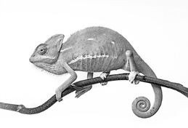
Chameleons are animals that change color. Many
chameleons are green, but sometimes they change
color to hide. For example, when chameleons
are on a tree and they feel afraid, they change
color to brown to look like the branches**. Some
chameleons change color to black when they want to
scare other animals away.
chameleon

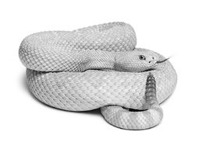
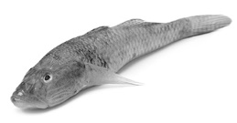
There are different kinds of fish that change color.
For example, goby fish change color when they
want to hide from dangerous sea animals. Goby
fish can be white when they swim near white rocks
or they can be red near red rocks.
There are animals that don't need to change color
to hide. For example, some snakes that live in the
desert are the same color as sand. This helps the
snakes hide and catch small animals.

Goby fish

1. Why do animals change color? –Tick TWO answers – סמנו 2 תשובות
to hide
to help other animals
to be colorful
to grow
to look dangerous

2. When do animals hide? - Write two answers – שתי תשובות
1. __________________________________________________
2. __________________________________________________

3. How do chameleons scare animals away? _________________________________________________________

4. Snakes in the desert don't need to change color because ___.
a their color is black
b they hide behind rocks
c they are dangerous animals
d they are the same color as sand

5. Which question has an answer in the text?
a When are snakes dangerous?
b When are goby fish white?
c What do chameleons eat?
d What colors do animals like?

Writing
Write 40-60 words about one of the following topics:

כתוב 60-40 מילים על אחד מהנושאים הבאים:

1. My favorite object.
2. Describe your family and what you like to do together.
________________________________________________________________________________________________________________________________________________________________________________________________________________________________________________________________________________________________________________________

